**Lesson 5 Demo 2**

**Perform Grouping in PivotTable**



**Steps to be followed:**

**Step 1: Open the Excel file**

* 1. Open the file named **Pivot Table.xlsx** and worksheet **Data**

**Step 2: Creating a pivot table**

2.1 Click on **PivotTable** under the Insert tab

2.2 In the **Create PivotTable** dialog, select the input range and choose a **New Worksheet** for the pivot table

2.3 Click on the Pivot table in the new sheet to get the Fields list. Choose Pivot fields as shown below. The Rows should be **Years** and **Dates**. The Value should be **Count of Net Sales**

2.4 Click on **Value Field Settings** in Net Sales

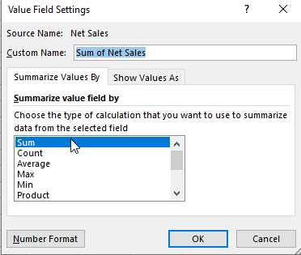

2.5 Choose **Sum** and click **OK**

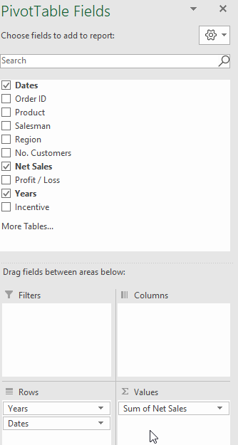

2.6 The output of the new pivot sheet looks like the following

